Biography Project

*A biography is a story of a real person's life and is written by another person.
Book Choice Due on ______________________

Poster Due ___________________
You may not use the same book from your 3rd grade biography reports!
Book Ideas: Abe Lincoln-the Boy Who Loved Books, NBA Superstar Shaquille
O'Neal, The Story of Ruby Bridges, any of the “I Am” or “Who Was” books from Scholastic. For this book report you will create a Biography poster.
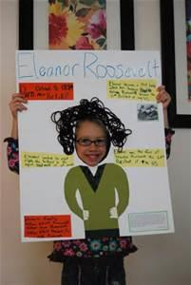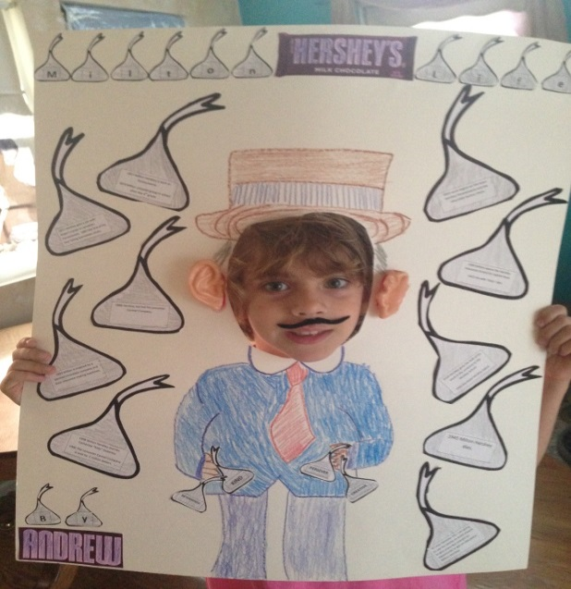
Cut a circle out of a poster board to become the person in the biography you have read. The poster is to look as much like the researched person as you can create by adding creative details. The face of the presenter, you, will be the face of the person researched.
1) Make sure you write the name of your person at the top of your poster in large letters.
2) Also, please attach the outline form to the back of the poster.
3) Add the information from the outline (at least 5 well developed facts) to the front of the poster around the edges. Remember to use complete sentences.
4) Be ready to talk about your person/poster.
5) I have white poster board please; let me know if you need one from me. You may use any color.
6) Your name and class # should be written on the back top right corner of your poster.
I have read the attached Biography Book Poster Guidelines and understand that the poster is due on _______________________________.
Book Title: __________________________________________________________
Student Name: ______________________________
Parent Signature: ____________________________

I have read the attached Biography Book Poster Guidelines and understand that the poster is due on ________________________________________.
Book Title: __________________________________________________________
Student Name: ______________________________
Parent Signature: ____________________________

I have read the attached Biography Book Poster Guidelines and understand that the poster is due on _____________________________________.
Book Title: __________________________________________________________
Student Name: ______________________________
Parent Signature: ____________________________

I have read the attached Biography Book Poster Guidelines and understand that the poster is due on ____________________________________.
Book Title: __________________________________________________________
Student Name: ______________________________
Parent Signature: ____________________________

