HAUNTED HOUSE
MYSTERY BOOK REPORT

Due Date: ______________________________________
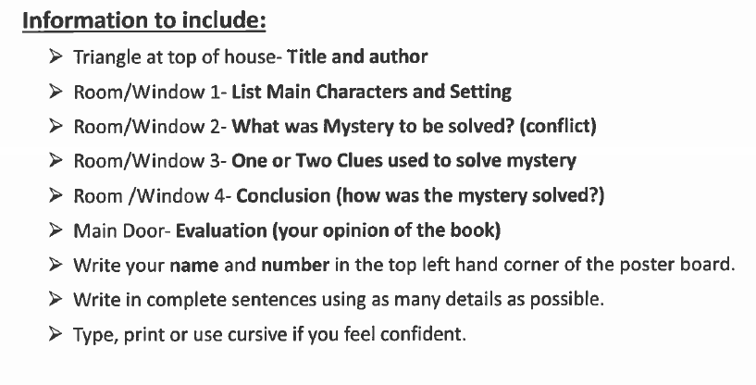
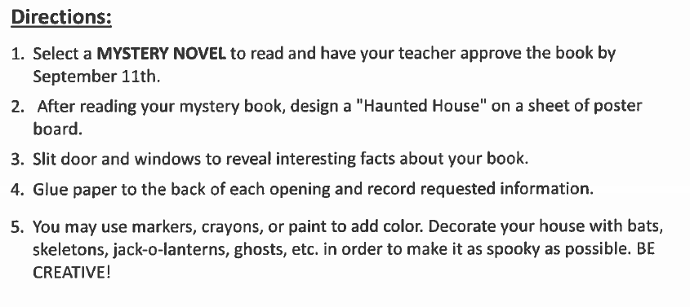

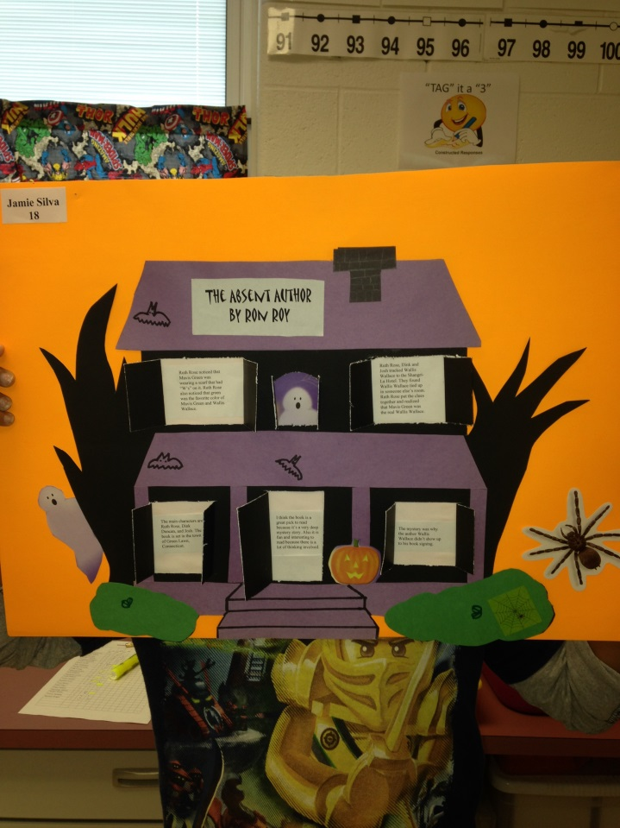
SAMPLE:

Return the bottom portion to your teacher by : ___________________________
-------------------------------------------------------------------------------------------------------------

